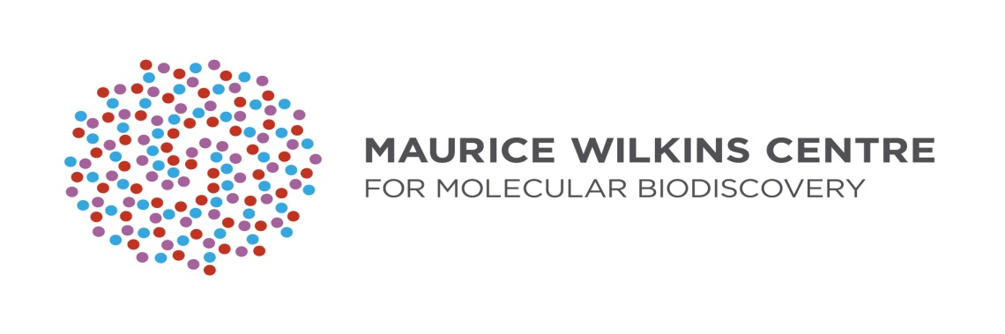

**“Scholarship to attend queEnstown research week meeting”**

**28th to 30th August at Rydges Hotel in Queenstown**

**(see www.queenstownresearchweek.org)**

QRW and The Maurice Wilkins Centre are pleased to offer three scholarships for high-school biology teachers to attend the Queenstown Molecular Biology science conference to be held from the 28th – 30th August 2023 at the Rydges Hotel, Queenstown, New Zealand.

The purpose of this scholarship is to provide New Zealand’s Science teachers with:

1. exposure to cutting edge research from National and International Scientists.
2. links with some of New Zealand’s leading researchers.
3. links with providers of scientific equipment and supplies.
4. links with top science teachers from around New Zealand.

The scholarships will cover conference registration, accommodation, and travel to and from Queenstown.

This year the Queenstown lecture will be given by Professor David Julius – winner of the 2021 Nobel Prize in Physiology or Medicine.

Previous recipients have said:

“*I could be a student again, learning new things.*”

“*I was able to provide new and innovative ideas as well as up to date scientific information on these topics which would interest, stimulate and benefit our students…*”

“*QMB provided me with great stories about the journey involved in scientific discovery. … The award has also helped me to expand my professional network.*”

Applications should contain:  
- a short letter (250 words) stating why the applicant would like to attend.   
- a one page C.V.   
- the name and contact details of one referee

Further information can be obtained from Prof. Justin O’Sullivan (09 9239868; justin.osullivan@auckland.ac.nz), or from the QMB website (http://www.queenstownresearchweek.org). Applications should be made by email to Prof. Justin M. O’Sullivan ([justin.osullivan@auckland.ac.nz](mailto:justin.osullivan@auckland.ac.nz)) and must arrive no later than the 6th June. Successful applicants will be notified on the 18th June.